Kavya Gundala

04-01-2024

**RUNNING AN ETL WORKLOAD ON AZURE DELTA LAKE:**

**Creating an Azure Databricks resource:**

* Here, I’ve created a ADB resource “kavya_etl”.

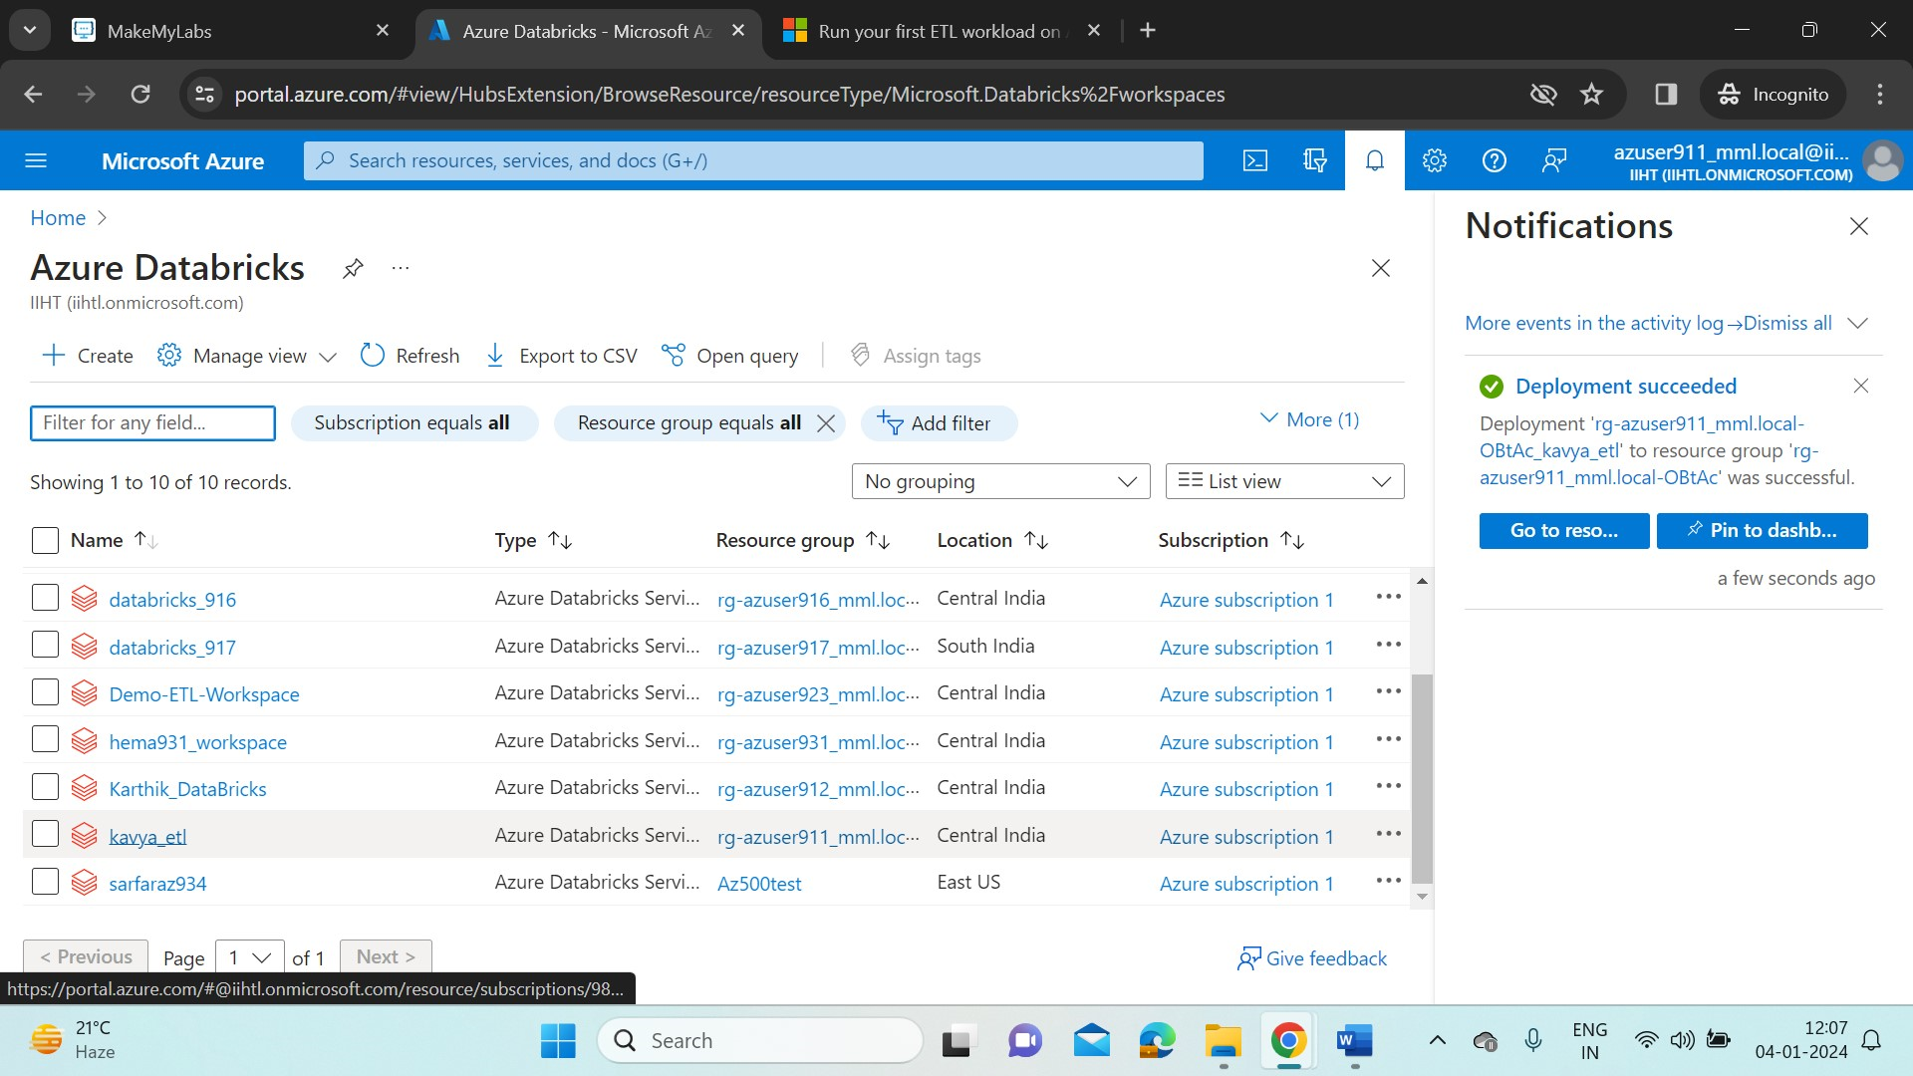

* When the deployment of the resource is completed, Go to resource and from there click on Launch Workspace. It will redirect us to Databricks portal.

**Creation of a cluster:**

* Select Compute on the side bar of Databricks portal, and start creating a cluster. Here I’ve created a cluster “kavya_ETL_cluster”.

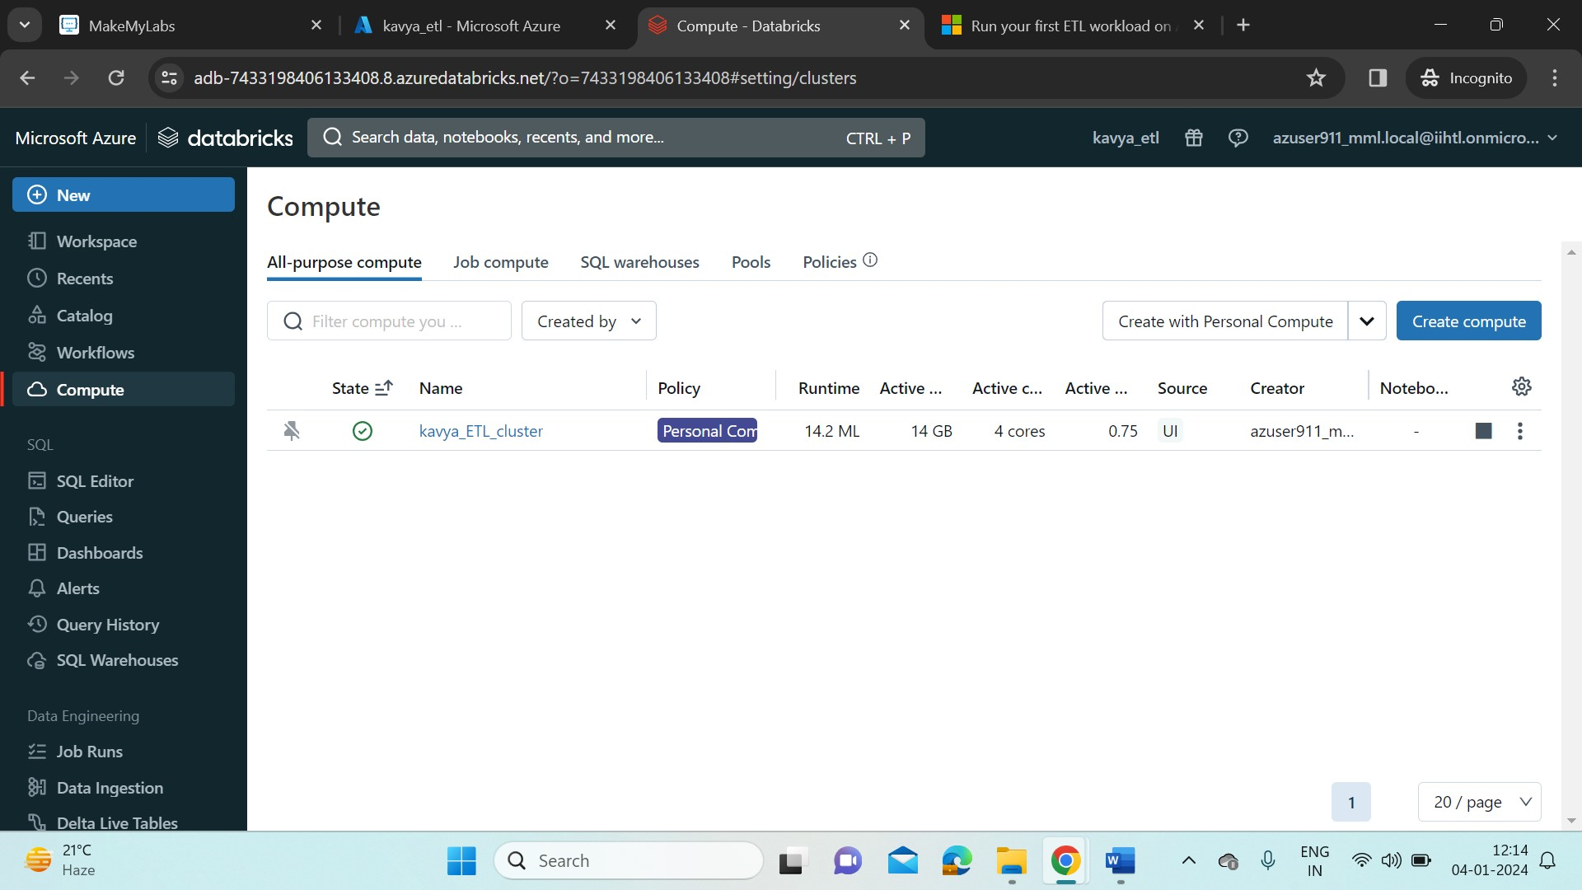

**Configure Auto Loader to ingest data to Delta Lake:**

* We configure Auto Loader for incremental data ingestion. Auto Loader automatically detects and processes new files as they arrive in cloud object storage.
* Delta Lake is an open source storage layer that provides ACID transactions and enables the data lake house. Delta Lake is the default format for tables created in Databricks.
* Now, To configure Auto Loader execute the following commands in Python.
* Create a notebook “kavya_etl1” .

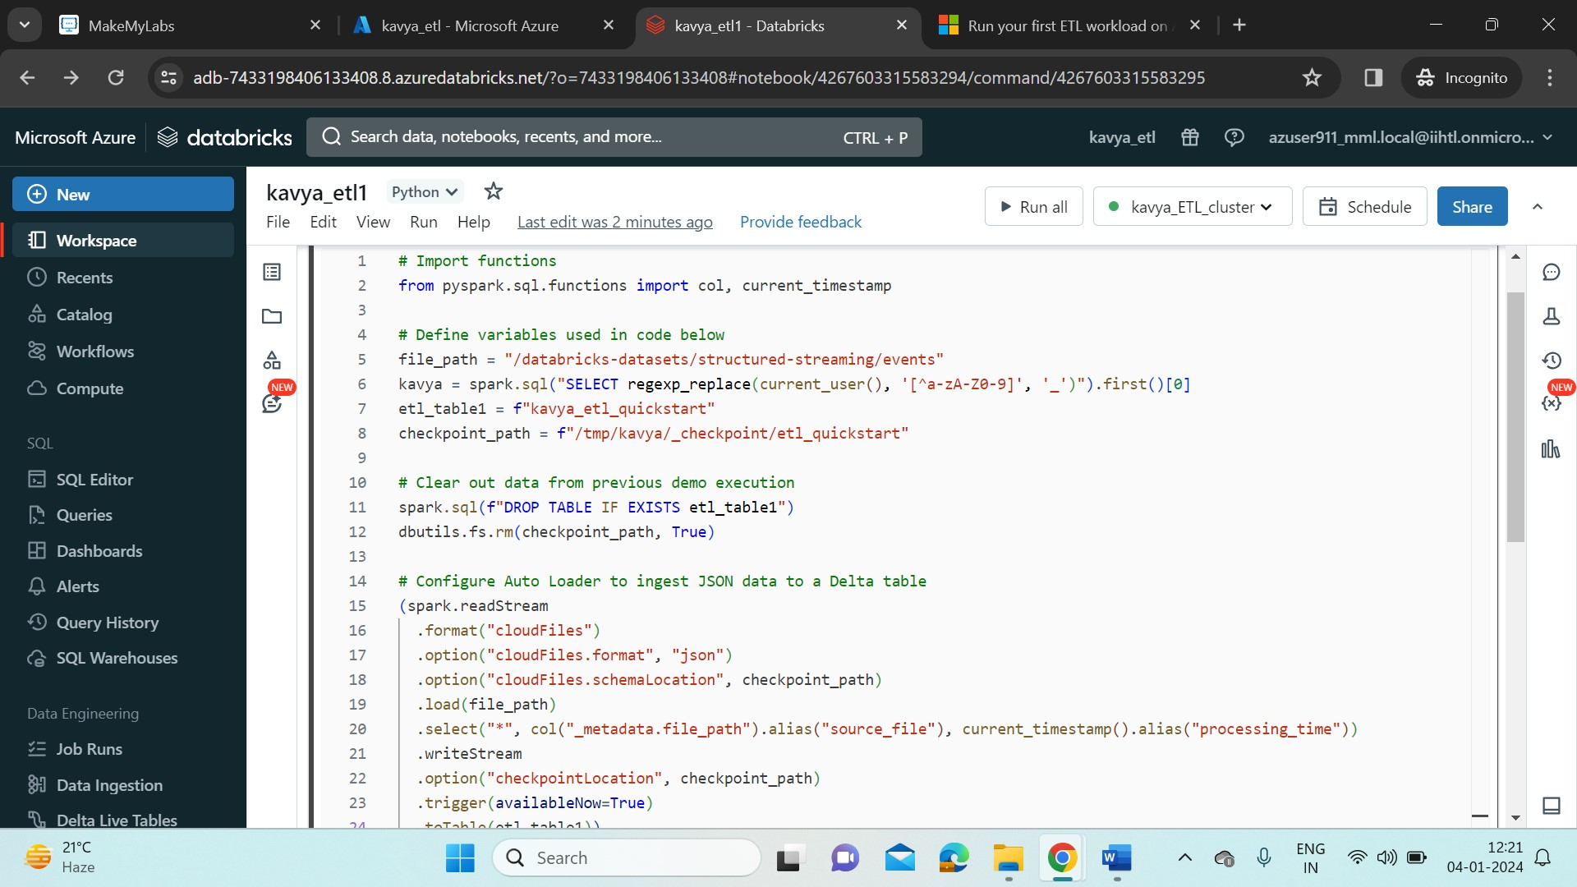

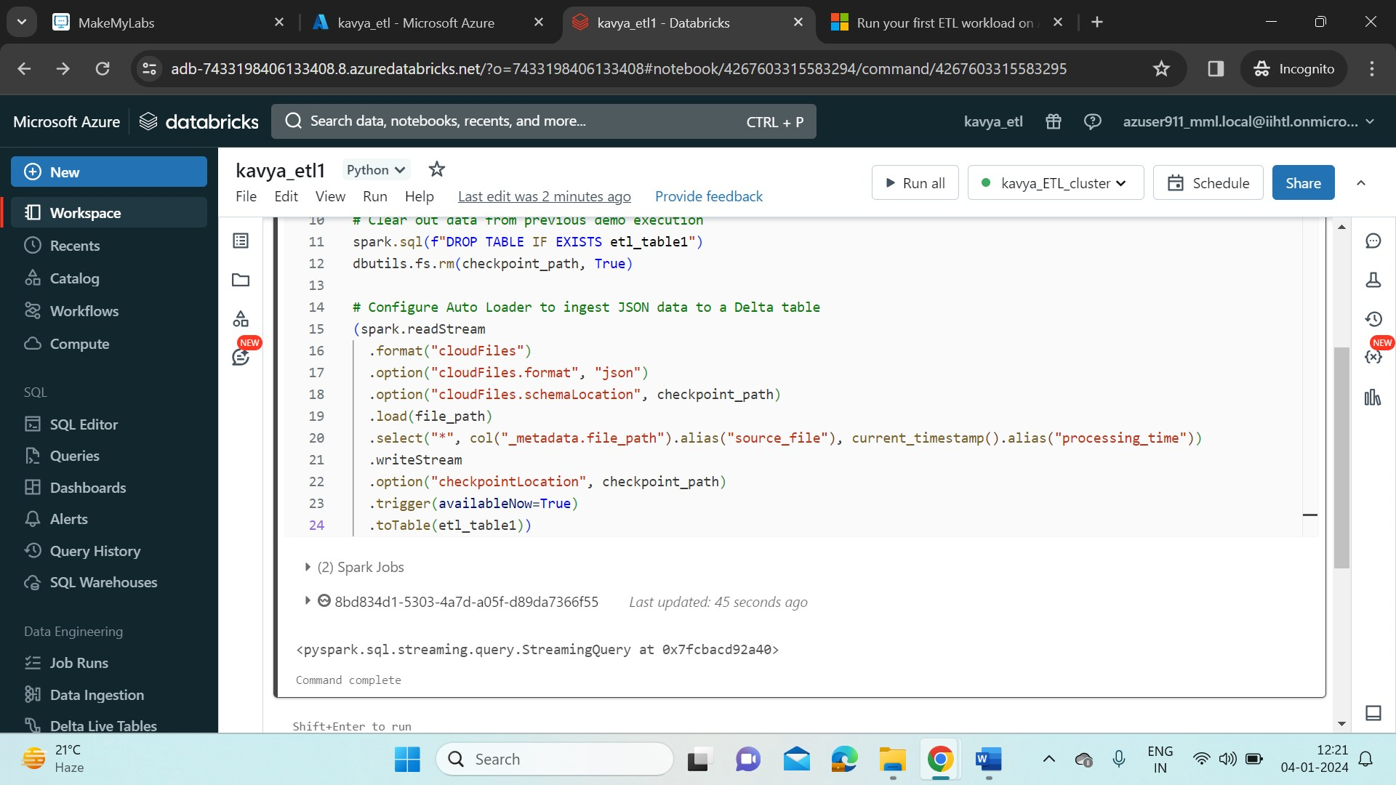

**Process and Interact with data:**

* To query the table run the below command.

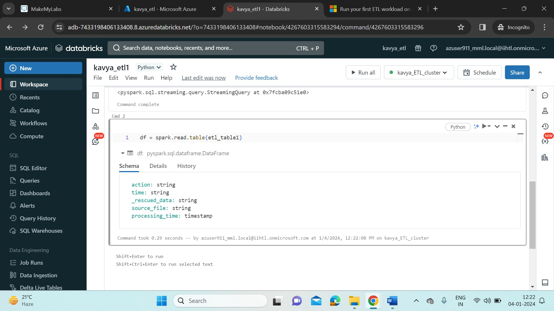

* To preview the data in the created DataFrame,

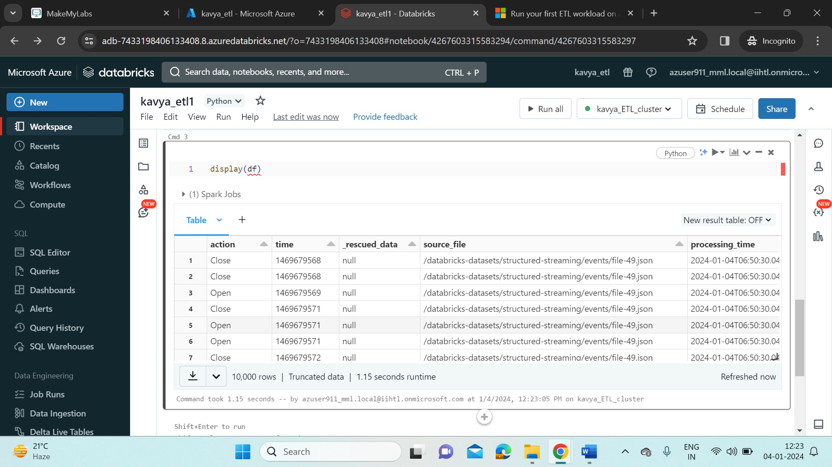

**Schedule a job:**

* To schedule the notebook as a task, click on the “Schedule” on the right side of the header bar.
* Create a job “kavya_etl1” and select the cluster that we’ve created. Here, I’ve scheduled the job as manual. So it only executes when I run it.
* We can also select Schedule and provide the timestamp.
* Click on Create.

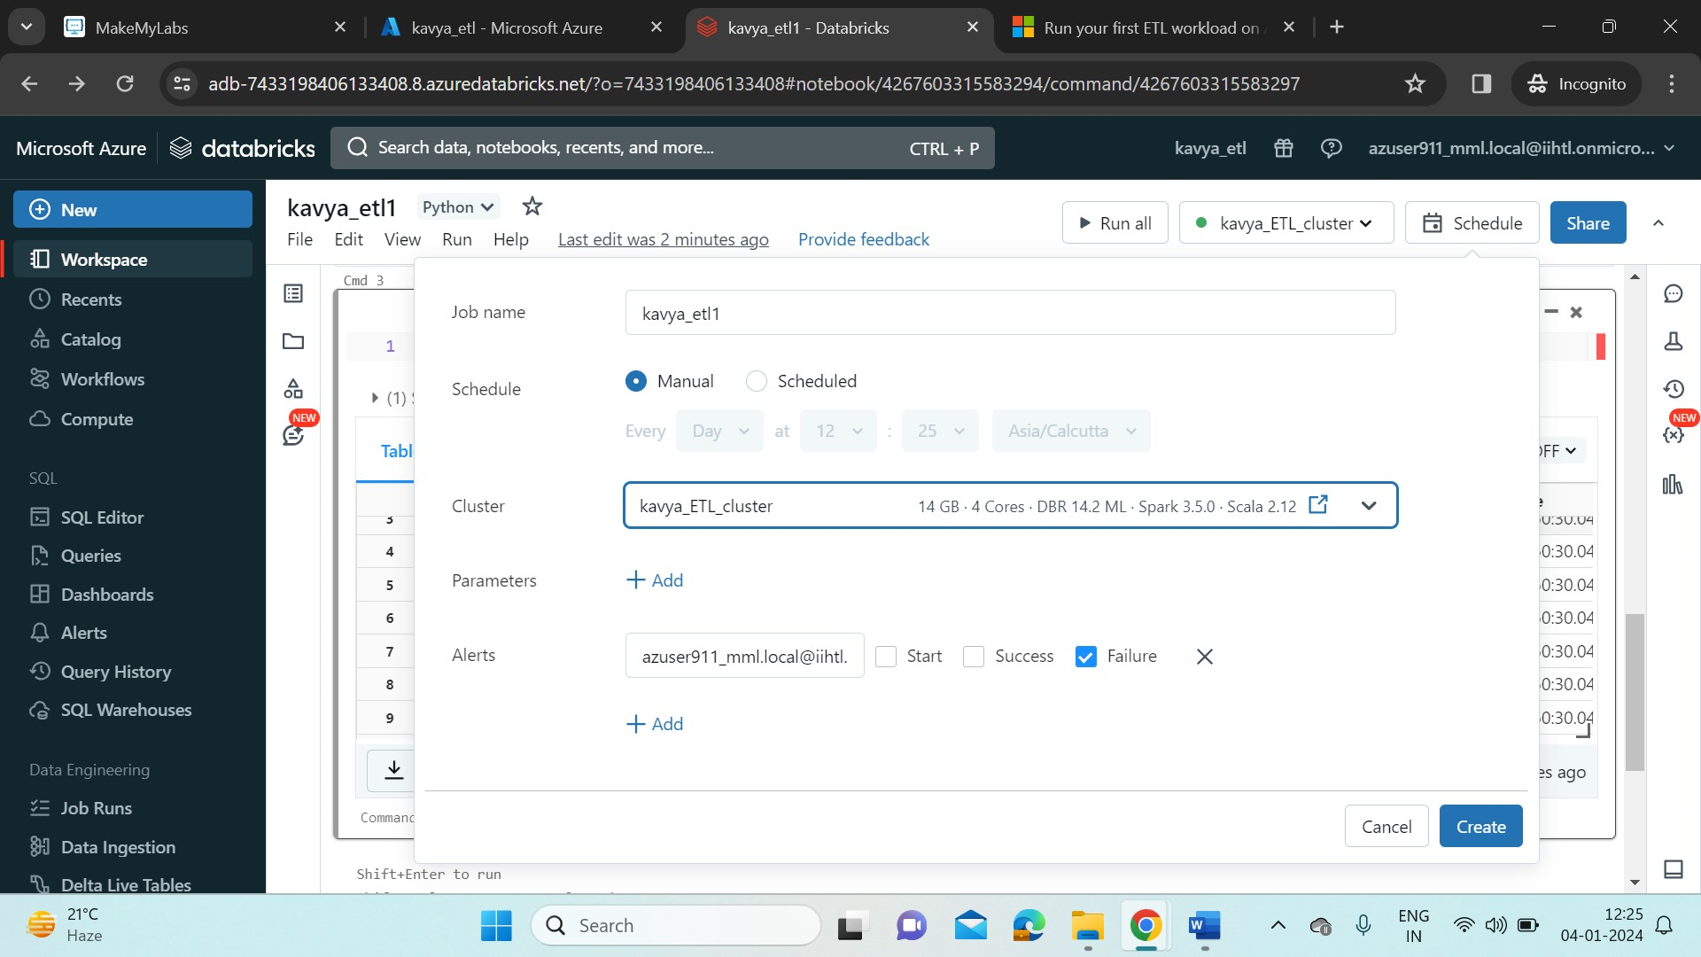

* Now , A dialog box appears , Click on Last run and it will open the jobs scheduled in a new page.

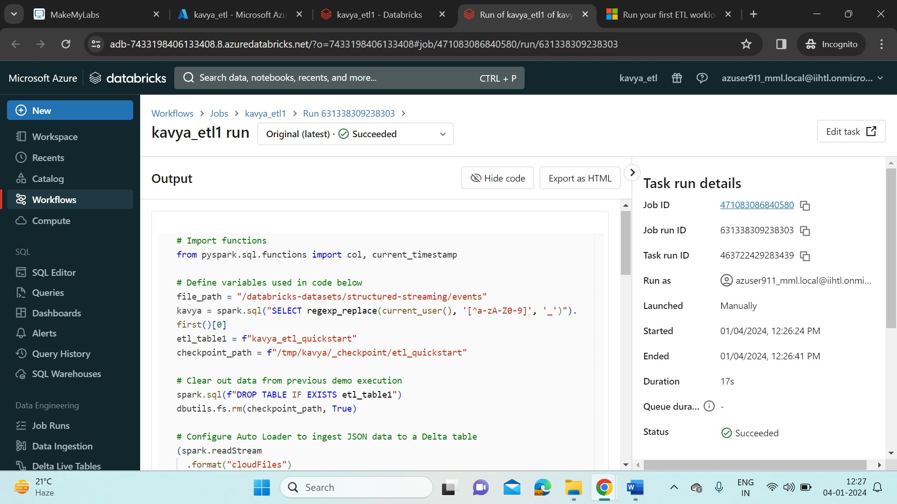

* Here we can see the status of the task as “Succeeded”.
* Now come back to the notebook and start visualizing the data in pie chart.

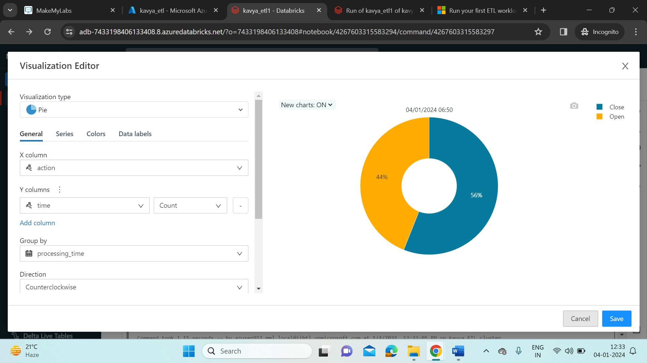

* Also add data Profile to our data.

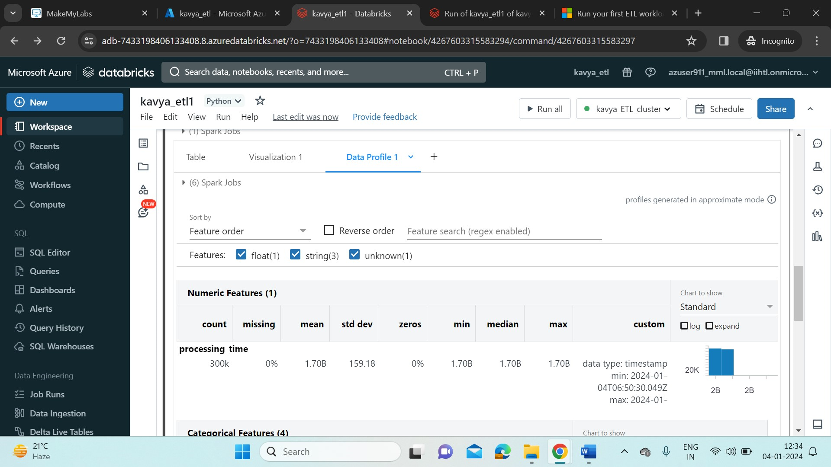

* Now again, run the task again. We can see the Visualization added to the job because we configured the Auto loader in our notebook.

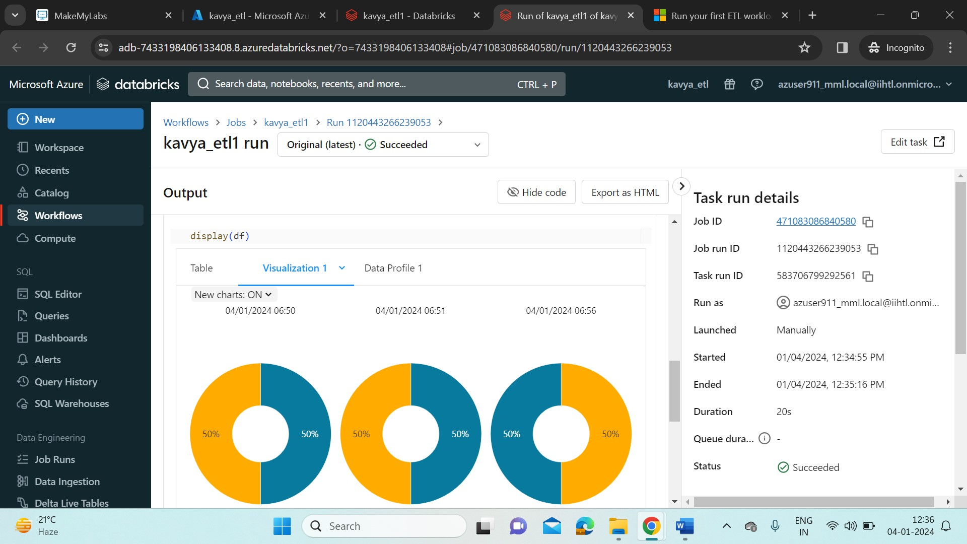

* We can see the available jobs in the “Job Runs” available in side bar of the Databricks portal.

